# Data Planning Brief – Trustpilot Funnel Analysis

## Project Description

Decision (or purchase) funnel analysis is an important tool for understanding the customer journey from first point of contact to purchase. This project will provide an analysis of the Trustpilot decision funnel and will consist of three elements for the UK and Italy:

1. Static Funnel
2. Dynamic Funnel
3. Causal Impact Analysis (CIA)

Upon availability of the relevant data, the Data Planning team will conduct static and dynamic funnel analysis for both UK and Italy. The dynamic funnel analysis will depend on a feasibility check to establish whether there is sufficient data to establish relationships between the different metrics.

In addition, the Data Planning team will conduct a causal impact analysis (CIA) to provide an early indication of the campaign success. This will measure campaign impact against a single, jointly agreed KPI that can be tracked on a regular basis.

## Background and Previous Insights

## Fees

|  |  |  |
| --- | --- | --- |
|  | **UK** | **Italy** |
| Part 1 | £4,000 + VAT | £4,000 + VAT |
| Part 2 | £10,000 + VAT | £10,000 + VAT |
| Mid-campaign dip (C.I.A.) | £6,000 + VAT | £6,000 + VAT |
| Total for each market | £20,000 + VAT | £20,000 + VAT |
|  | | |
| **2 markets total** |  | **£40,000 + VAT** |

## Interested Parties and Roles

* Henry Johnston-Ellis (Data Planning, MG OMD) – Funnel Analysis
* Shanice Henderson-Quartey (Effectiveness, MG OMD) – Effectiveness Lead

## Proposed Funnel Design

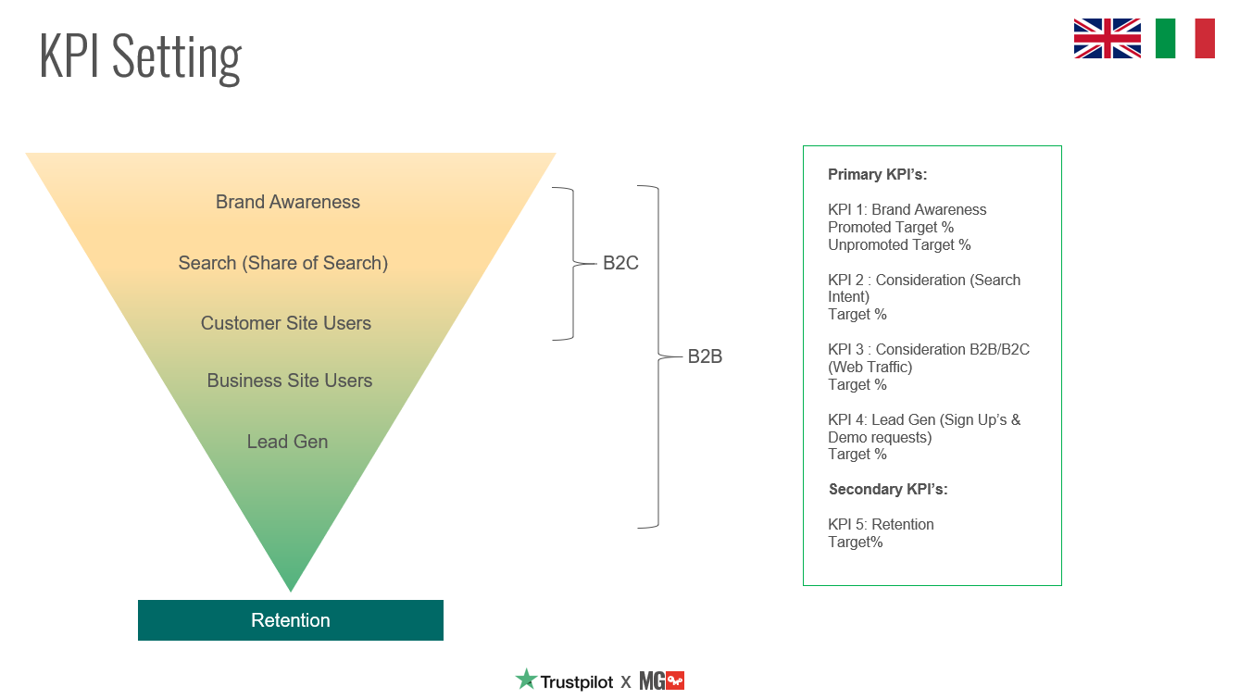

## Delivery

**Clarifying timings for delivery**